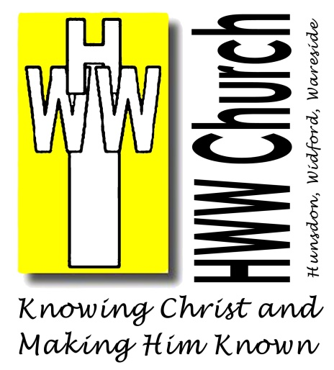
Church@Home

Sunday 22nd March 2020

True Family

Dear Brothers and Sisters,

Here are the resources to accompany the order of service for this week’s worship.

If you are reading this document online, the underlined sections are hyperlinks to online resources (Bible readings hymn music or other recordings). You can access the resource by simply clicking the link.

You can hear the sermon either by using the hyperlink or by telephone – calling (01279) 967111. Your normal call charges will apply (so if you have a “free minutes” deal, it will be free!). If you do this before 9am Sunday you may hear me read a poem by Lewis Morrison called “Cockrobin Lane”.

Please let me know whether this is helpful and what might make it more so.

With prayers for you all and love in Christ Jesus,

Revd Mark Dunstan
Sentence of Scripture
For this reason, I kneel before the Father, from whom every family in heaven and on earth derives its name. I pray that out of his glorious riches he may strengthen you with power through his Spirit in your inner being, so that Christ may dwell in your hearts through faith.
(Ephesians 3:14-17a)

Hymn 1 For the beauty of the earth

Collect for Mothering Sunday

God of love,
passionate and strong,
tender and careful:
watch over us and hold us
all the days of our life;
through Jesus Christ our Lord.
Amen

Reading 1 Hebrews 3:12-14

Hymn 2 Beneath the Cross of Jesus

Reading 2 John 19:25-27

Creed (cf Ephesians 3)

Let us declare our faith in God.

We believe in God the Father,
from whom every family
in heaven and on earth is named.
We believe in God the Son,
who lives in our hearts through faith,
and fills us with his love.

We believe in God the Holy Spirit,
who strengthens us
with power from on high.

We believe in one God;
Father, Son and Holy Spirit.
Amen.

Sermon Telephone (01279) 967111 or

Access sermon online

Prayers
You are invited to pray in your own words.
Here are some suggested topics:

Church:
- Our local fellowships as we learn what it means to be the church without being able to gather
- Our leaders, including our Archbishop, Justin, and Bishops, Alan and Michael
World:
- Our government and others dealing with the Coronavirus pandemic
- For medical staff and other frontline carers
- For grieving families and anxious communities
- For a spirit of selflessness amongst the people

You might like to use the following prayer, written by the Director of Church Society, Revd Dr Lee Gatiss:

Heavenly Father,
our ever-present help in trouble,
our fortress and our God:
calm the anxious fears of all who turn to you;
give strength and healing to those who are sick,
and courage and skill to those who care for them;
grant wisdom and clarity to those in authority;
and humble us all to call upon you that we may be saved
not only in this life, but also for that which is to come,
through Jesus Christ our Lord. Amen.

Community:
- Mothers – their families
- Those who find Mother’s Day difficult
- Our neighbours and friends and all who are worried in our villages about the virus.

Rejoice that God has promised through his Son, our Saviour Jesus Christ, to hear us when we pray in faith.

Hymn 3 We are one in the Spirit
Blessing
The Lord bless you and keep you;
the Lord make his face shine on you
and be gracious to you;
the Lord turn his face toward you
and give you peace.
(Numbers 6:24-26)

Material in this service has been reproduced from Common Worship © 2000 Archbishop’s Council

